**HANDS-ON AGGREGATE FUNCTIONS & ROLL UP —------------------------------------------------------------------------------------------------------------------**

**Tables: Features, Sales, Stores**

| **AGGREGATE FUNCTIONS:**   * MIN() - Gives the minimum value from the record. * MAX() - Gives the maximum value from the record. * SUM() - Adds and gives the sum of the entire record. * AVG() - Gives the average value of an entire record. * COUNT() - Gives the count of the entire record(no.of. rows). It does not include the Null values. |
| --- |

**1. Check the highest and lowest temperature from the Featured table.**

Select MAX(Temperature) as Highest_Temperature, MIN(Temperature) as Lowest_Temperature from Features

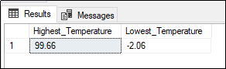

**2. Display the entire Weekly_Sales and the average Weekly_Sales.**

Select SUM(Weekly_Sales) as Entire_Sales, AVG(Weekly_Sales)as Average_Sales from Sales

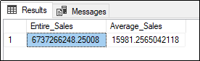

**3. How many types of ‘B’ records are present in the Stores table?**

Select COUNT(Type) as Total_TypeB from Stores Where Type ='B'

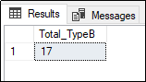

| **SQL ROLL UP:**  SQL Roll up will generate multiple grouping sets. Roll-up can be used along with the group by function. |
| --- |

**4. Give the total weekly sales value with the Date and Dept details. Use roll-up to pull the data in hierarchical order.**

Select Date, Dept, SUM(Weekly_Sales)as Total_Sale from Sales

group by Date, Dept

with Rollup

